Assessment task Unit 2APSY/2BPSY
Performance Lab report

TYPE: Investigation
OUTCOMES: Outcome 2: Investigating in psychology; Outcome 4: Communication in psychology
CONTENT: Unit 2APSY/2BPSY
UNIT CONTEXT: Healthy lifestyle/Diversity and community

Task 1: Performance Experiment (20%)
This investigation is similar to Task 21 (page 149) in Psychology: Self, Others and Society Workbook, Stage 2; an experiment that has ethics committee approval.

This experiment uses a repeated-measures design. That is, each participant is measured over two conditions. This helps reduce error due to variance between participants. This experiment will look at the impact high arousal has on cognitive performance during a maze completion task. Arousal can be thought of as levels of stress or anxiety, and can have a positive or negative influence on an individual’s behaviour.

You are to present your findings in the form of a laboratory report, no more than 2000 words and no less than 1500. Your lab report must be written to APA specifications, as per your Investigation Skills Handbook.

DUE DATE: Monday 25th August – Week 6

The background
With reference to the Yerkes-Dodson curve of performance, there is an optimal level of anxiety needed to reach maximum performance. Arousal (or anxiety) often manifests in many physiological ways: an increase in heart-rate, breathing-rate, and blood pressure; muscle contraction (tensing), and the release of certain hormones. Can physiological arousal also serve to improve performance for a brief period?

The activity
Participants will first complete the maze task at rest, before exercising vigorously for 2 minutes, after which participants will complete the second maze. Timing of maze completion with be conducted by a timer on a screen.

The support
Your final report will consist of an Abstract, Introduction, Method, Results, Discussion and a list of References used. Your report will also have one Appendix (the mazes used). The Investigation Skills Handbook given at the beginning of the year is crucial to ensure correct formatting, writing style and referencing.

You will be given a number of journal articles related to the topic. It is expected that you will use these and reference these in your report.

IMPORTANT
- This document and the Declaration of Authenticity can be found on Connect (https://connect.det.wa.edu.au) under “Class Library → Semester 2 Assessment Tasks”

- You must upload a copy of your report via Connect → Submissions, AS WELL as handing in a paper-copy.

Stage 2: Investigation marking key—PSY Student:__________________ Penalties: _______

ABSTRACT | Criteria | Description | Mark  Allocation | Allocated  Mark
ABSTRACT | Ability to clearly summarise the investigation in the abstract | - Clear and concise summary of the main aspects of the investigation in correct order  - Some details missing from parts of the abstract | 2  1
INTRODUCTION | Ability to identify and communicate the theory behind the investigation | - Provides succinct and detailed information about the theory behind the investigation  - Identifies broad aspects of the theory  - Identifies limited aspects of the theory | 3  2  1
INTRODUCTION | Ability to identify and communicate past research behind the investigation | - Provides succinct and detailed information about relevant research, referencing at least three articles  - Provides succinct and detailed information about relevant research  - Identifies and communicates some research | 3  2  1
INTRODUCTION | Evidence of clear understanding of aim | - Succinctly writes a specific aim  - Provides a general aim | 2  1
INTRODUCTION | Evidence of clear understanding of an hypothesis | - Writes research question/prediction as a hypothesis that follows on logically from the aim  - Poses a research question/prediction | 2  1
DATA  COLLECTION  METHOD | Clearly identifies and explains the participants used | - Participants described in sufficient detail to be replicated | 0-1
DATA  COLLECTION  METHOD | Clearly identifies and explains materials used | - Materials described in sufficient detail to be replicated | 0-1
DATA  COLLECTION  METHOD | Clearly identifies and explains the procedures. | - Describes procedures in sufficient detail to be replicated  - Insufficient details in the explanation of the procedures | 2  1
RESULTS | Appropriate summary of data | - Accurate and complete description of the data  - Accurate but limited description of the data | 2  1
RESULTS | Appropriate organisation of data | - Data organised into an appropriate, correctly labelled form e.g. tables, graphs etc  - Data organised into an appropriate form but labelling is missing or incorrect | 2  1
DISCUSSION AND EVALUATION | Accurate and thorough analysis and explanation of the data | - Draws accurate conclusions from the data, provides analysis, explains and supports conclusions with research articles | 0-4
DISCUSSION AND EVALUATION | Evaluation of findings | - Discussion of: extraneous variables, methodological flaws, ethical issues and suggestions for improvement or other aspects worth investigating | 0-4
DISCUSSION AND EVALUATION | Contribution to science and/or society | - Accurately discusses relevance of results to the population from which the sample was drawn (1), and links results to work of other researchers (2) | 0-3
REFERENCING  and APPENDICES | In-text referencing | - Accurate use of APA citation | 0-1
REFERENCING  and APPENDICES | In-text referencing | - Adequate use of citations | 0-2
REFERENCING  and APPENDICES | End-text referencing | - Provides three or more references (including 3 journals) | 0-1
REFERENCING  and APPENDICES | End-text referencing | - Accurate use of APA referencing | 0-2
FORMAT & WRITTEN EXPRESSION | Formatting of report | - Correct use and format of headings  - Double-spaced text  - Correct use of indentations | 0-1  0-1  0-1
FORMAT & WRITTEN EXPRESSION | Sentence structure | - Well structured sentences | 0-1
FORMAT & WRITTEN EXPRESSION | Grammar & Spelling | - Correct grammar, punctuation and spelling | 0-1
FORMAT & WRITTEN EXPRESSION | Use of appropriate scientific report language | - Use of appropriate scientific language, including the use of 3rd person and past tense | 0-1
Comments |  |  | 43 | /43

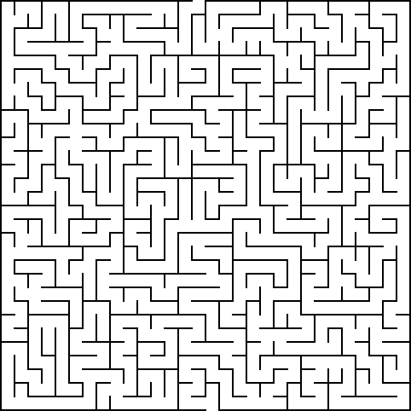

Figure 1. Maze 1.

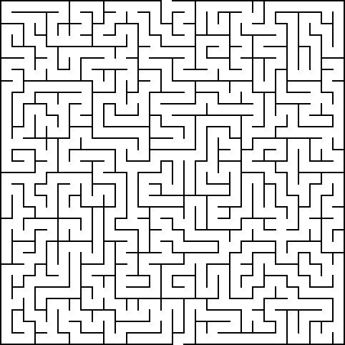

Figure 2. Maze 2

Figure 1 and 2 were generated from http://www.mazegenerator.net/ which uses an algorithm to create mazes to specific variables. Both mazes were 30 x 30 cells in size. Each maze had an ‘elitism value’ (E-value) of 50 and a river tendency (R-value) of 100. (An elitist maze has a short solution relative to the size of the maze, while a non-elitist has a solution going through a larger portion of the maze. A maze with a high river factor has few but long dead ends, while on with a low river factor will have many short dead ends.)

